Name: ***2-title.png***

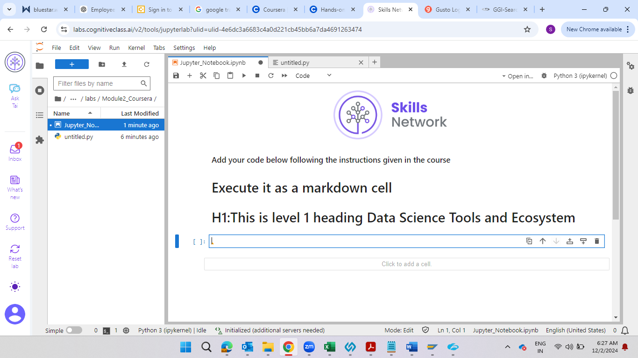

Name : ***3-intro.png***

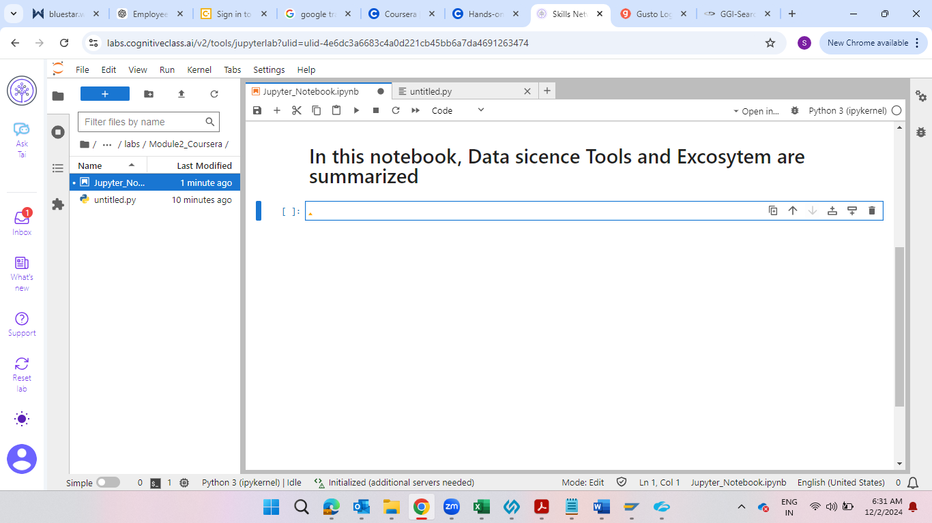

Name: ***4-dslanguages.png***

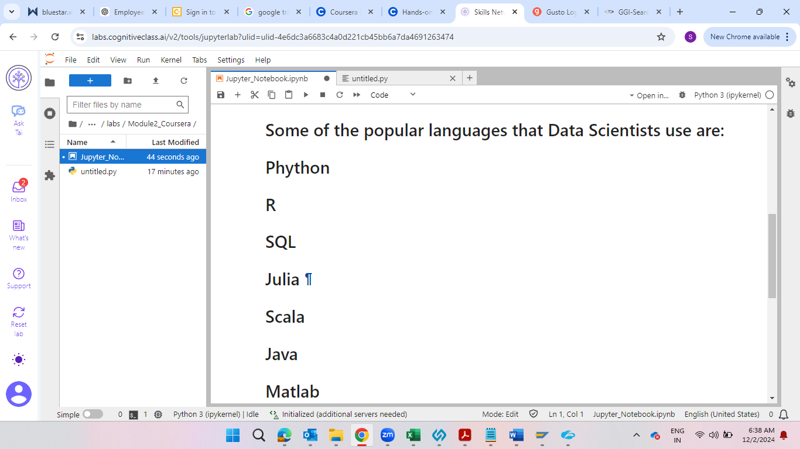

Name : ***5-dslibraries.png***

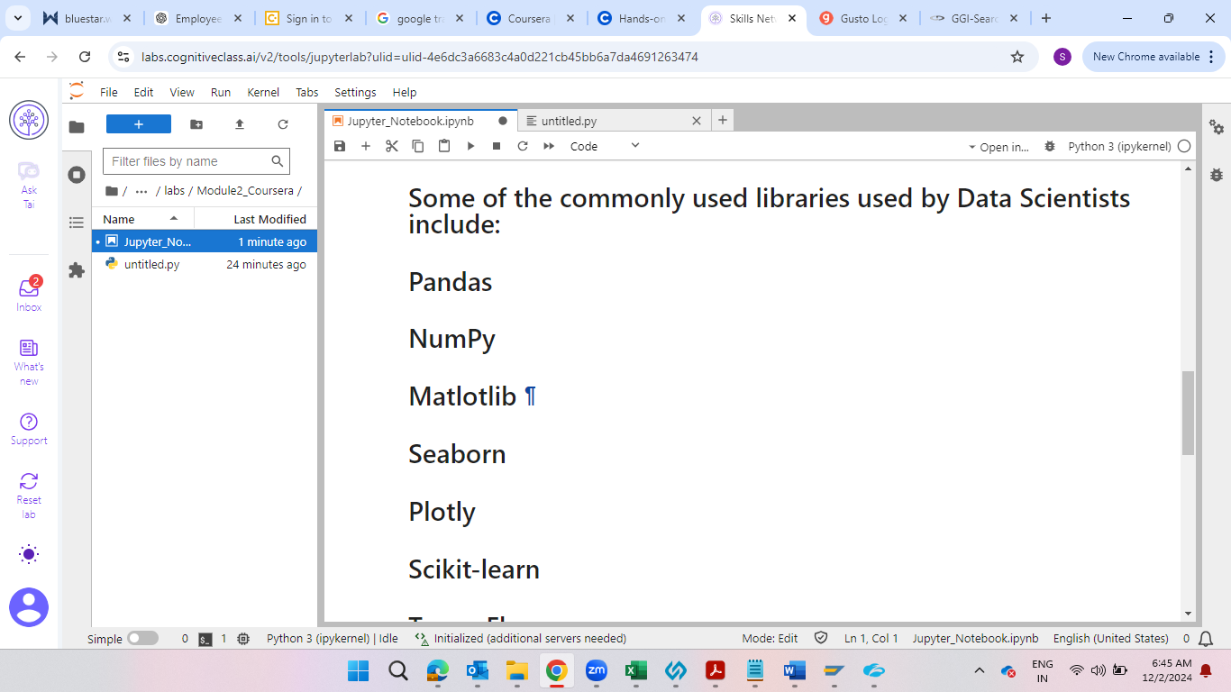

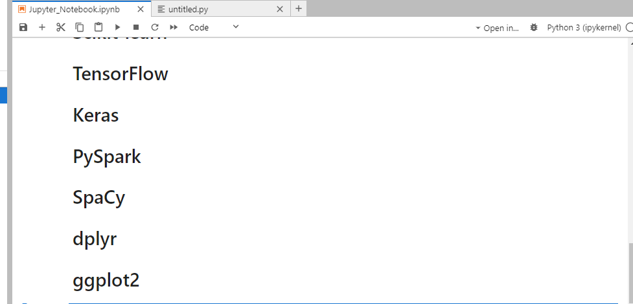

Name : ***6-dstools.png***

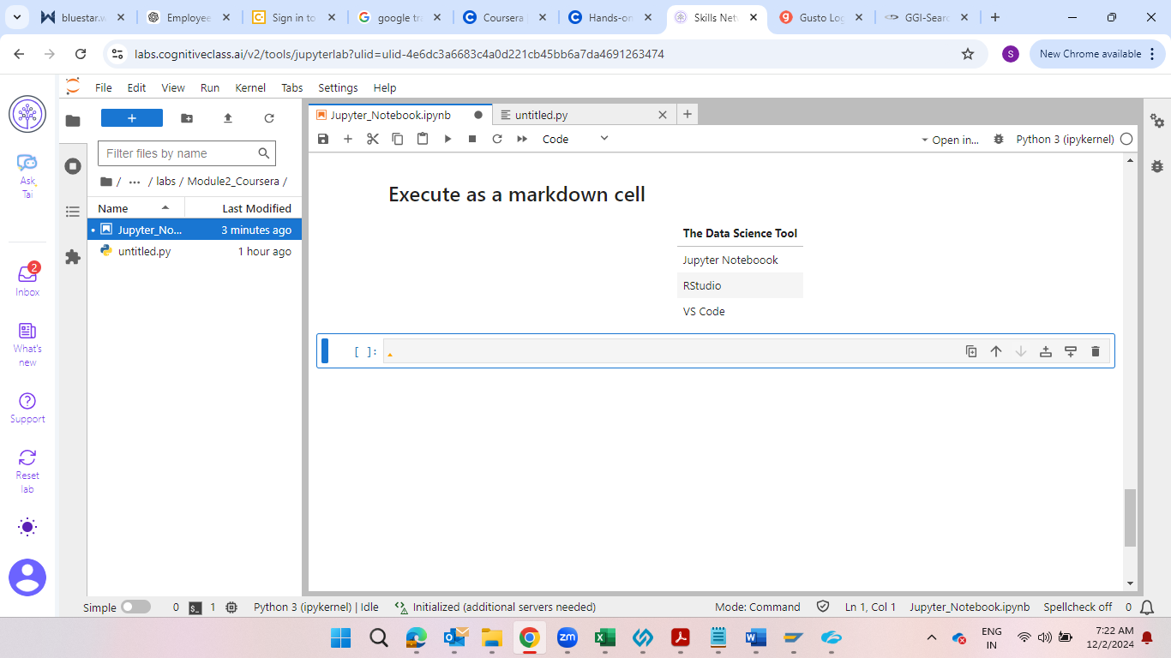

Name : ***7-introarithmetic.png***

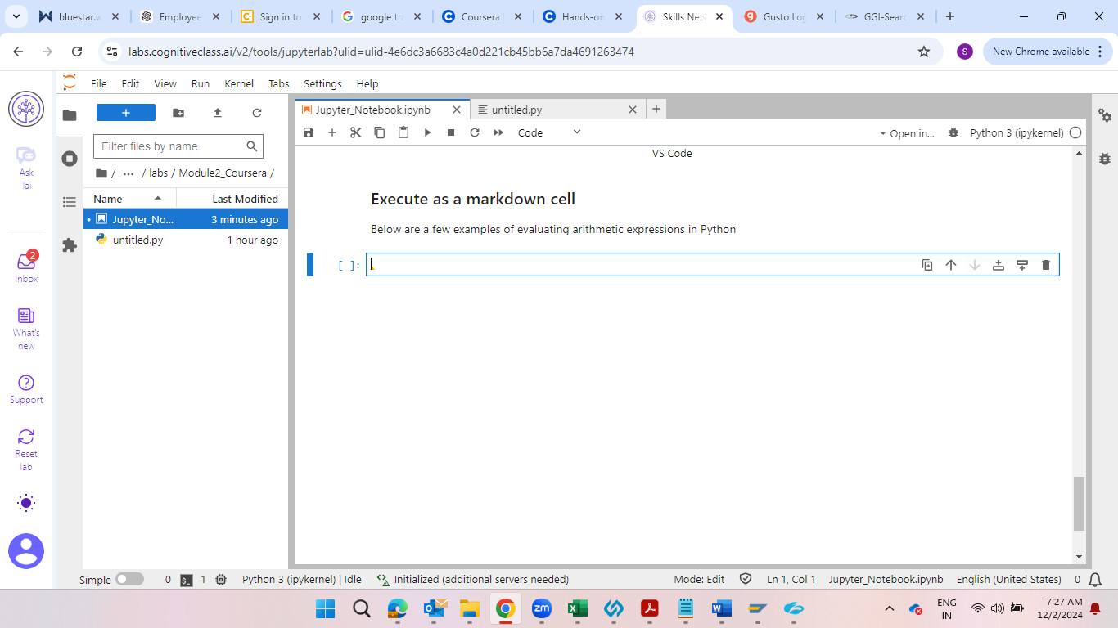

Name : ***8-multiplyandaddintegers.png***



Name : ***9-hourstominutes.png***



Name : ***10-objectives.png***

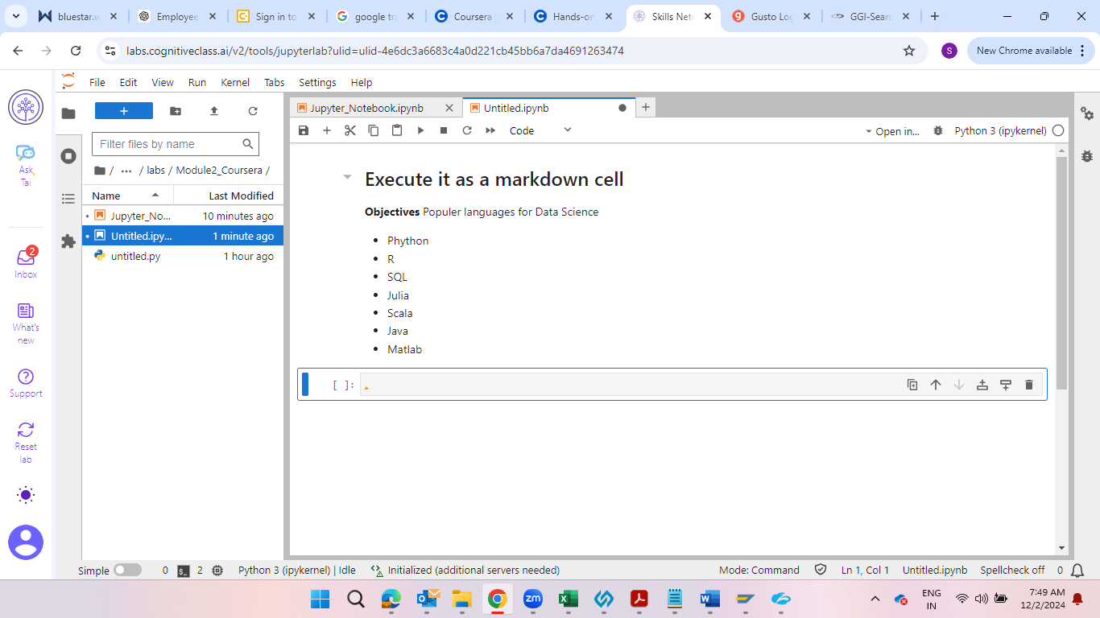

Name: ***11-authordetails.png***

